Team Profile - Yashraj

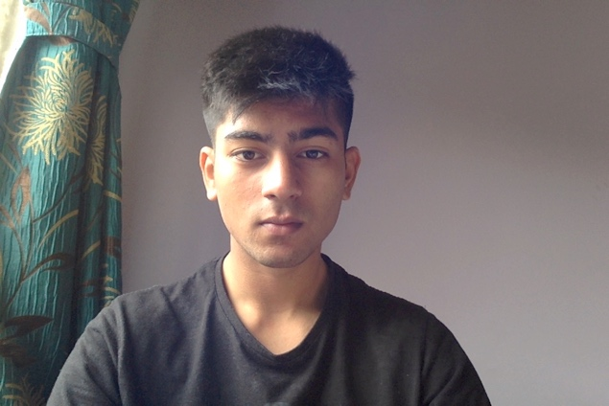

Personal Information: Greetings, my name is Yashraj Mewada, some of my friends call me ‘Yash’, some call me raj and some call me by my full name. My student number is s3841523, email address is [yashrajcmewada@gmail.com](mailto:yashrajcmewada@gmail.com) . I was born and raised in India till the age of 7 where I moved to Australia. My nationality is Australian and ethnicity is Indian, I speak both English and Gujarati. I have relatively little experience in IT, so far I’ve learned a bit of coding, SQL and databases, and a bit UI designing experience. Some hobbies that I have are travelling and being outdoors, playing sports or going to the gym, watching movies and anime

Team profile:

Michael: In the Myer Briggs test Michael was an ISTP- Adventurer, Michael stands out to be more logical and organized, someone who can take charge of a conversation and lead it. This test gives a sense of direction in his personality as he tends more logical and analytical. Michael learning style is shown to be a Tactical learner who is shown to have a ‘hands on’ understanding of things. His personality trait score shows that his somewhat of an open person, conscientious about his work, his extroverted, an agreeable guy and has extreme natural reactions.

Arin:

Arin Briggs test concludes with him being a Campaigner, who is thought to be a ‘free spirit’, he seems to be a very independent person and is open to discussions and group collaboration. Arin’s learning style is a visual learner which tells me that he understands by looking at something rather than writing. His personality trait score shows that his fairly all rounded in most areas and is extremely agreeable.

Robert: For the Myer Briggs test Robert got the same result as me; a mediator, the role usually deals with controlling the tone of a conversation. Like Arin, Robert seems to be a visual learner who learns by visually seeing something. His personality trait scores somewhat imbalanced as he has a 100% on openness, mid 50’s % in conscientiousness and Extraversion, 77% in agreeableness and a 27% in natural reaction, a very mixed result.

Wen: For the Myer Briggs test Wen’s personality type was a consul, which means he cares about other people’s feeling and keeps them in consideration.He is visual learner like Arin and Robert where he learns by viewing things instead of it being explained or written. His big five personality test scores show that he is extremely well balanced and is hovering between 55%-65% In all five categories.

Ben:

Ideal Jobs:

Michael: Michael’s ideal job is Software engineer in contrast to my ideal job which is a data analyst, Michael’s job is more oriented towards designing new software and creating solutions for them while my job is more focused on analyzing data and creating information through it.

Wen: Wen’s ideal job is game designer which is completely in a different field in terms of IT fields as his job is directed towards designing games while my ideal job is to more related to dealing with data and information.

Arin: Arin’s ideal job is software programmer which is more focused on programming and coding which is mainly for while my ideal job is analyzing data and gathering information that would be useful different parties.

Robert: Robert’s ideal job is a cyber Security Analyst which is very similar to my ideal job as a data analyst, his job mainly focuses on finding and analyzing any possible threats or breakouts within a program or software and have prevention measures for them, while my job focuses on cleaning up clunky data and creating visually appealing information.

Ben: